**Assignment**

**CSA0814 – Python Programming**

|  |  |
| --- | --- |
| **Register Number** | **192324198** |
| **Name** | **HARIGOWTHAM.A** |

**Title:**

XML Parser

**Problem Statement:**

Create a Python program that parses XML data from a file using the xml.etree.ElementTree module, extracts relevant information, and presents it in a human-readable format or performs specific actions based on the data.

**Code:**

**XML File (‘library_data.xml.txt’)**

<library>

<books>

<book id="1">

<title>Python Programming</title>

<author>John Doe</author>

<publisher>

<name>TechBooks Publishing</name>

<year>2020</year>

</publisher>

<price>29.99</price>

</book>

<book id="2">

<title>Advanced Algorithms</title>

<author>Jane Smith</author>

<publisher>

<name>DataSci Publishers</name>

<year>2018</year>

</publisher>

<price>35.50</price>

</book>

<book id="3">

<title>Machine Learning Insights</title>

<author>Emily Johnson</author>

<publisher>

<name>AI Research House</name>

<year>2022</year>

</publisher>

<price>45.00</price>

</book>

</books>

<authors>

<author id="1">

<name>John Doe</name>

<nationality>American</nationality>

<birthyear>1980</birthyear>

</author>

<author id="2">

<name>Jane Smith</name>

<nationality>British</nationality>

<birthyear>1975</birthyear>

</author>

<author id="3">

<name>Emily Johnson</name>

<nationality>Canadian</nationality>

<birthyear>1990</birthyear>

</author>

</authors>

</library>

**Python Program (‘xml_parser.py’)**

xmlfile = "library_data.xml.txt"

import xml.etree.ElementTree as ET

def parse_xml(xmlfile):

tree = ET.parse(xmlfile)

root = tree.getroot()

print("Books in the library:")

for book in root.find('books').findall('book'):

title = book.find('title').text

author = book.find('author').text

publisher = book.find('publisher').find('name').text

year = book.find('publisher').find('year').text

price = book.find('price').text

print(f'Title: {title}, Author: {author}, Publisher: {publisher}, Year: {year}, Price: {price}')

print("\nAuthor Information:")

for author in root.find('authors').findall('author'):

name = author.find('name').text

nationality = author.find('nationality').text

birthyear = author.find('birthyear').text

print(f'Name: {name}, Nationality: {nationality}, Birth Year: {birthyear}')

parse_xml('library_data.xml.txt')

**Output:**

Books in the library:

Title: Python Programming, Author: John Doe, Publisher: TechBooks Publishing, Year: 2020, Price: 29.99

Title: Advanced Algorithms, Author: Jane Smith, Publisher: DataSci Publishers, Year: 2018, Price: 35.50

Title: Machine Learning Insights, Author: Emily Johnson, Publisher: AI Research House, Year: 2022, Price: 45.00

Author Information:

Name: John Doe, Nationality: American, Birth Year: 1980

Name: Jane Smith, Nationality: British, Birth Year: 1975

Name: Emily Johnson, Nationality: Canadian, Birth Year: 1990

**Output Screen Shots:**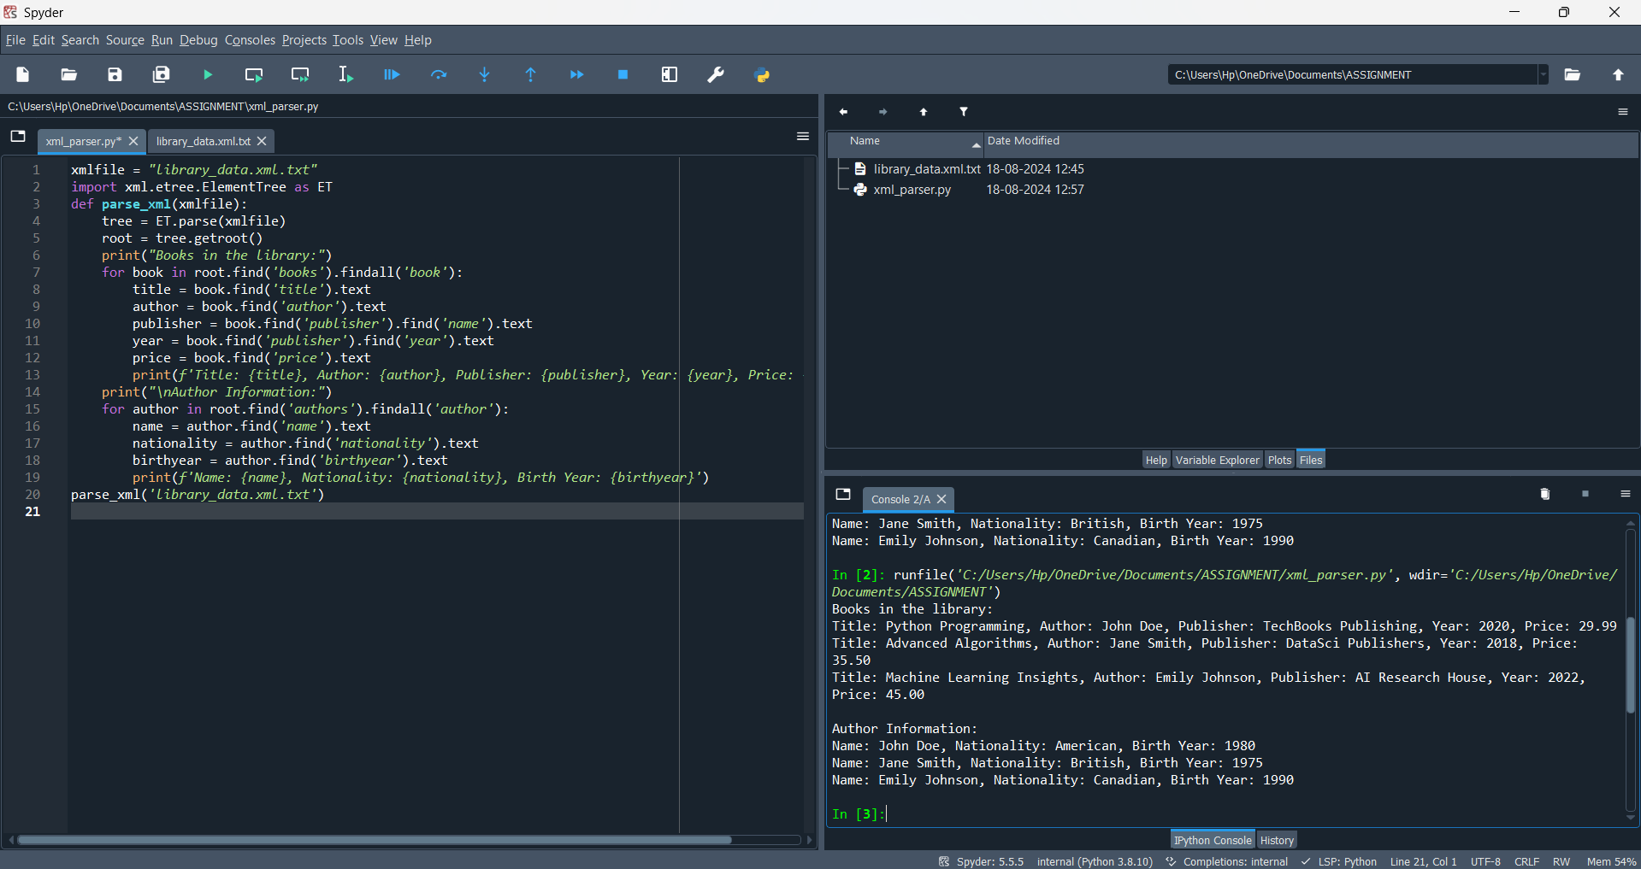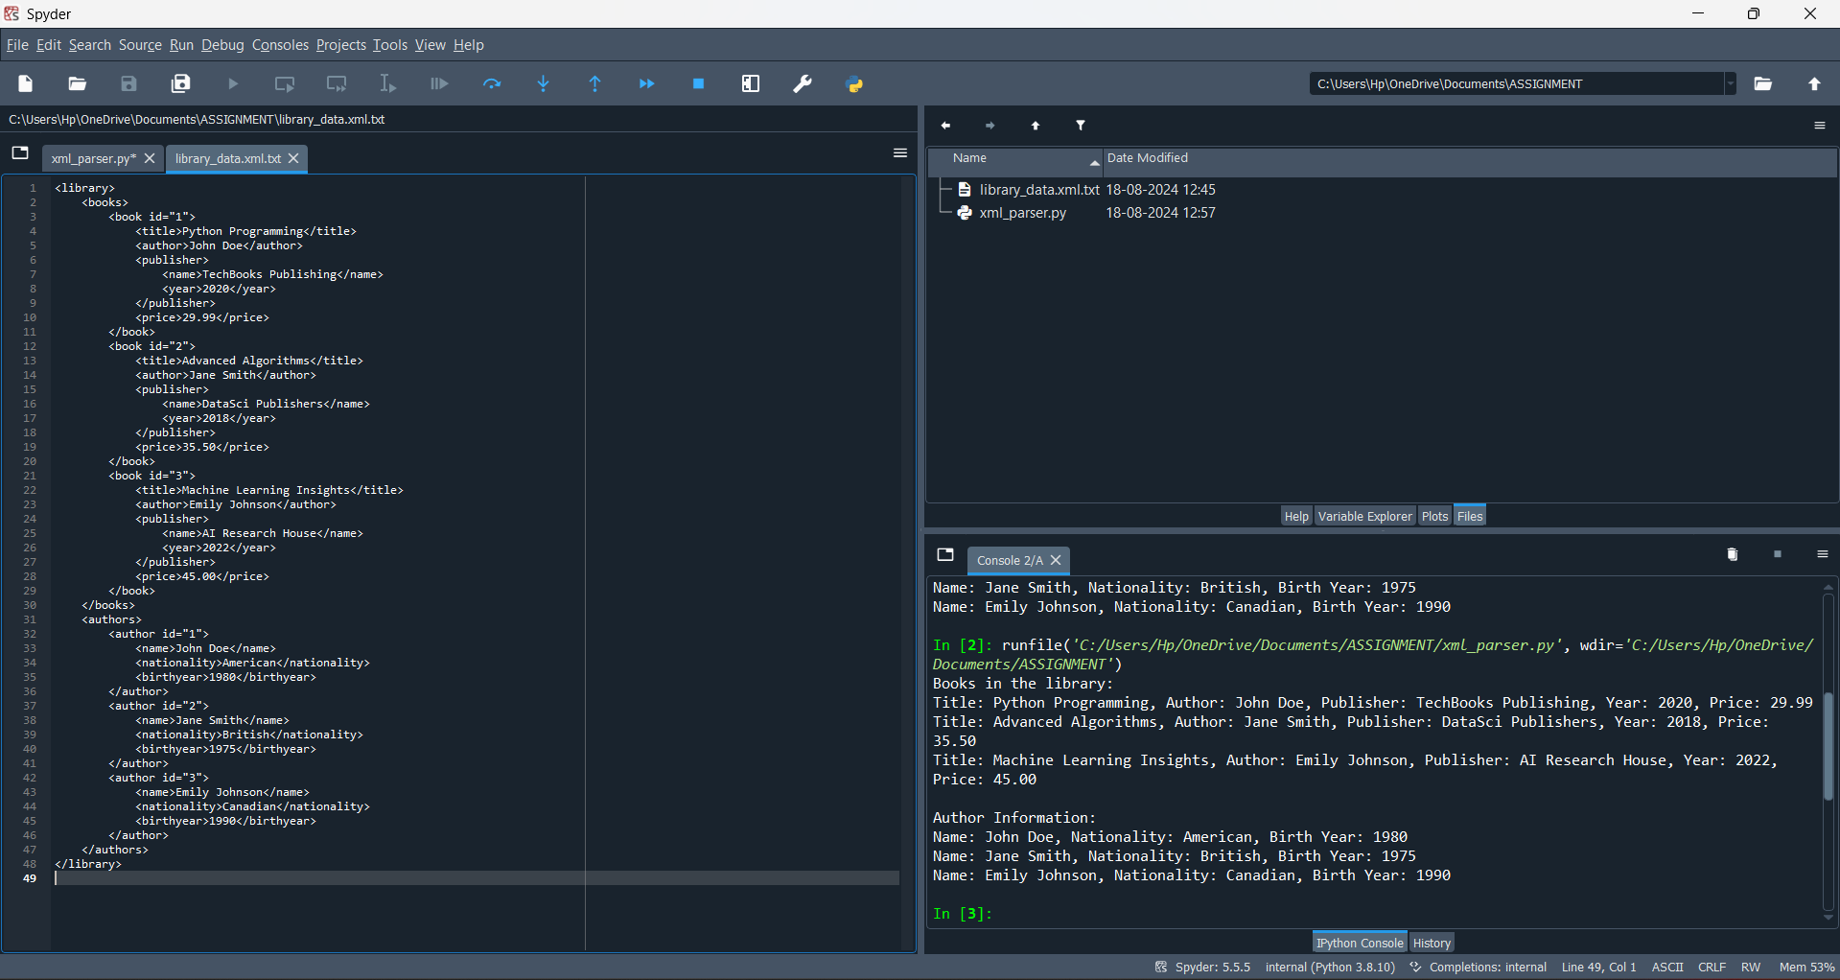

**Conclusion:**

**Multiple Sections**: The XML file contains both books and authors. The program handles each section separately, extracting data from nested elements.

**Nested Elements**: The program extracts information such as the publisher name and year, demonstrating how to handle nested XML structures.

**Readable Output**: The extracted data is printed in a human-readable format.

This approach shows how to handle larger and more complex XML files in Python, while maintaining a clean structure.